13 April 2026
NAME: HAUWA’U ALIYU | Age: AD | Sex: F | Ref No:00010
Clinical Details: OBS |  |  |  | US:10
OBS REPORT
Maternal Survey:
Internal Os is closed.
Adnexa ppear unremarkable.
Foetal Survey: -
- Sonogram revealed SINGLE intrauterine foetus.
- Presentation : BREECH, lying transverse
- Placenta Location : ANTERIOR
- Amniotic fluid : ADEQUATE
- Cardiac activity : PRESENT AND REGULAR

Biometry:
- Gestation age based on BPD, HC, AC and FL is approximately (GA): 24 weeks 01 day(s)
- Expected date of delivery by USG DD) : 03/08/2026 (± 2 weeks)
- Foetal weight : 0.9kg
- Gender : XX
IMPRESSION: Single term intrauterine foetus at 24 weeks 01 day(s). Presenting BREECH.
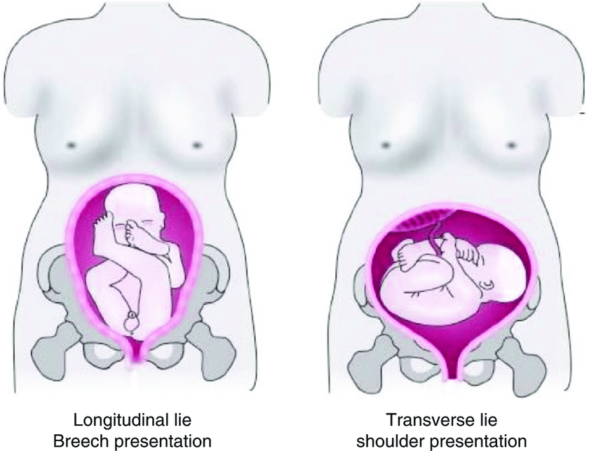
Ultrasound Specialist

